**Children Hospital’s Ambulance Transfer Data Analysis**

Elizabeth Chin

Health Informatics, University of Pittsburgh

April 21, 2023

**Introduction:**

Data analysis has become an integral part of decision-making in various fields, including healthcare. With the advent of technology and the accumulation of large amounts of data, it is crucial to develop tools to analyze and interpret this data effectively. One such tool is Power BI, a business analytics service by Microsoft that provides interactive visualizations and business intelligence capabilities with an interface designed to create dashboards and reports.

The Children's Hospital of Pittsburgh is a leading medical institution renowned for providing exceptional care to children. As part of their commitment to providing world-class medical services to their patients, they collect and analyze data related to their ambulance transfers. The goal is to gain insights into the referrals, to improve the quality of care and better serve the medical needs of their young patients.

This report outlines my capstone project on Power BI using 3-month referral data from Children’s Hospital of Pittsburgh. The project aims to analyze and visualize referral data for pediatric patients to identify patterns and trends to help healthcare providers make informed decisions. The Children’s Hospital generates vast amounts of data, and analyzing this data can provide valuable insights into patient outcomes, hospital operations, and healthcare trends. Understanding these factors is crucial in providing effective healthcare and improving the overall health outcomes of patients.

**Background:**

For this project, I created a Power BI dashboard to analyze the three-month referrals of Children's Hospital of Pittsburgh ambulance transfers. The dashboard is designed to provide insights into the various aspects of ambulance transfers, such as admission date, inpatient and emergency admissions, ambulance usage, and reasons for the visit. To ensure compliance with HIPAA and PHI laws, I took the necessary precautions to ensure the safe masking of all healthcare information.

The project will focus on using hospital data to identify patterns, trends, and insights related to patient outcomes and hospital operations. The data will be obtained from the Children Hospital in Pittsburgh, and it will include information on patient demographics, length of stays, diagnoses, treatments, and readmissions. The data will be analyzed using various visualizations and tools available in Power BI.

In addition to the insights gleaned from the data visualization and analysis done with Power BI, my capstone project also highlighted the importance of data governance and quality control. Throughout the process of collecting, cleaning, and analyzing the data, I encountered numerous inconsistencies and errors that required careful attention and correction. For example, I found inconsistent naming conventions for ambulances, and missing data in key fields such as zip codes. Addressing these issues was critical to ensuring that the analysis was accurate and reliable, and it underscored the importance of having clear guidelines for data management and quality control. Moreover, the project helped me to appreciate the complexity of the healthcare system and the numerous challenges involved in collecting and analyzing data from disparate sources. Some of the issues encountered in the project may have broader implications for healthcare providers and policymakers, including the need for more standardization in medical records and the importance of investing in data infrastructure that can support robust analysis and reporting.

**Objectives**:

The primary objective of this project is to provide insight into the 3-month referrals of the ambulance transfers for Children's Hospital of Pittsburgh. The project is intended to help healthcare professionals better understand the referrals and facilitate informed decision-making. Specifically, the following metrics were tracked: the number of inpatient and emergency admissions, the volume of ambulance utilization, and the patients' reasons for visiting the hospital. By analyzing the data, I aim to gain insights into the various factors that influence ambulance transfers, such as geographical location, age, and gender of the patients, complaints, and reason for the visit.

**Literature Review**:

Laura B. Madsen's book "Data-Driven Healthcare: How Analytics and BI are Transforming the Industry" explores the role of data analytics and business intelligence (BI) in transforming the healthcare industry. The book presents real-world examples and case studies from various healthcare organizations, demonstrating how data-driven insights can lead to improved patient outcomes, reduced costs, and better operational efficiencies (Madsen).

Madsen explains the various data sources in healthcare and the challenges associated with collecting, integrating, and analyzing them (Madsen). She also provides an overview of the key technologies and tools used in healthcare analytics and BI, such as electronic health records (EHRs), clinical data warehouses, and data visualization tools. The book covers several use cases of healthcare analytics and BI, including population health management, clinical decision support, revenue cycle management, and quality improvement. Madsen also addresses important considerations around data privacy, security, and governance in healthcare.

Overall, "Data-Driven Healthcare" is a comprehensive guide for healthcare professionals, analysts, and executives looking to leverage data and analytics to improve patient outcomes and operational efficiencies in the healthcare industry.

Patrick Siarry is a renowned researcher and professor in the field of optimization and artificial intelligence. His work focuses on the development of intelligent algorithms for optimization and decision-making problems. In the book "Big Data Analytics in Healthcare," edited by Anand J. Kulkarni and published by Springer Nature, Siarry contributes a chapter titled "Intelligent Optimization for Healthcare Analytics." In this chapter, he discusses the role of intelligent optimization techniques in the field of healthcare analytics (Kulkarni).

Siarry argues that with the growing availability of large amounts of healthcare data, there is a need for efficient and effective methods for analyzing this data to improve patient outcomes and reduce costs (Kulkarni). He proposes the use of intelligent optimization algorithms, such as genetic algorithms, simulated annealing, and particle swarm optimization, to help healthcare professionals make informed decisions based on the analysis of big data.

Siarry presents case studies that demonstrate the effectiveness of intelligent optimization techniques in various healthcare applications, including disease diagnosis, treatment planning, and resource allocation. He concludes that intelligent optimization techniques have the potential to revolutionize healthcare analytics and improve the quality of care for patients.

Deepak Gupta is an expert in the field of big data analytics and its applications in healthcare. In the book "Applications of Big Data in Healthcare: Theory and Practice" authored by Ashish Khanna and published by Academic Press, Gupta provides insights into how big data can be utilized in the healthcare industry to improve patient outcomes, reduce costs, and enhance efficiency.

The book focuses on the key concepts, methods, and tools of big data analytics and how they can be applied in the healthcare sector (Khanna). Gupta discusses various applications of big data in healthcare such as personalized medicine, predictive analytics, disease management, and population health management. He also highlights the challenges and opportunities associated with big data implementation in healthcare, including data privacy and security concerns.

Gupta's contribution to the book provides readers with a comprehensive overview of the potential benefits of big data in healthcare and the critical role it can play in transforming the healthcare industry (Khanna). His insights offer valuable guidance to healthcare professionals, policymakers, and researchers seeking to harness the power of big data to improve patient care and outcomes.

**Methodology**:

In order to achieve the objectives of the study, the methodology involved several sequential stages. These stages included data collection, data cleaning and transformation, and data visualization using Microsoft Power BI tool. The data collection process involved the identification and collection of data from referral sources into a single data warehouse. To ensure data accuracy and completeness, the collected data underwent a thorough cleaning process that involved removing duplicates, missing values, and outliers. The transformed data was then used to import onto Power BI. Finally, the Power BI tool was used to visualize the data into interactive and dynamic dashboards.

Furthermore, this methodology was intended to provide a detailed overview of how data from Pittsburgh Children's Hospital was collected, transformed, and visualized. It allowed the identification of patterns and trends within the data sets through interactive visuals, and the development of recommendations through effective decision-making. The methodology is a crucial aspect of this study as it outlines the steps that were taken to ensure the integrity and consistency of the data, as well as providing a clear understanding of the questions that were answered through data visualization using Power BI.

The data collection process for this project involved obtaining data from the electronic medical records (EMRs) of patients at Children’s Hospital Pittsburgh (CHP). The data was obtained from the CHP data warehouse, which is managed by the hospital's IT department. The dataset included patient demographic information, admission details, disposition, complaints, medical record number (MRN), etc. The data was collected over a period of three months, from January 1st, 2023, to March 31st, 2023. Data sources were primarily generated from the EMRs of inpatient and outpatient encounters that occurred during this period. The data was collected using a secure and HIPAA-compliant process, with access restricted to authorized personnel. Prior to the commencement of data analysis, the dataset was cleaned, and any errors or inconsistencies were corrected. Data de-identification was also performed to ensure patient privacy and confidentiality. This involved masking or removing any personally identifiable information, such as patient names, text fin, numeric fin, etc. The final dataset contained a total of 2,661 patient encounters, providing a rich resource for data analysis using Power BI. The accurate and detailed data collection process enables us to conduct meaningful analysis to identify trends and patterns in patient care, which can be used to optimize clinical workflows and improve patient outcomes.

My capstone project also demonstrated the effective illustration of the data visualization and interpretation. I made use of various chart types, such as tables, pie charts, and bar charts, to present the data effectively. The presented data was efficiently interpreted and helped the hospital staff in understanding the trends and patterns of patient demographics, hospital performance, and other critical information. The layout and design of the visualizations were strategically planned to make them more readable and understandable to the intended audience. For example, I used specific color-coding shading schemes to distinguish from most to least in ambulance group, age, and complaints.

In addition, I incorporated various interactive features, such as drill-throughs and filters, that helped the end-users to dynamically change the data displayed on the dashboard. For example, I can drill down ED admissions by month, year, day of week, and arrival hour based on the filters I created. Another interactive feature I created is a geo mapping of all the zip codes that represents the location of ambulance transfers, which allowed me to better understand the distribution of referrals. In one of my classes from this semester, I learned that a person’s zip code remains a more accurate determinant of health than his or her genetic code.

This made the data visualization more user-friendly and responsive. The dashboard was also designed to be accessible on mobile devices, allowing hospital staff to make informed decisions from anywhere, at any time.

**Results**:

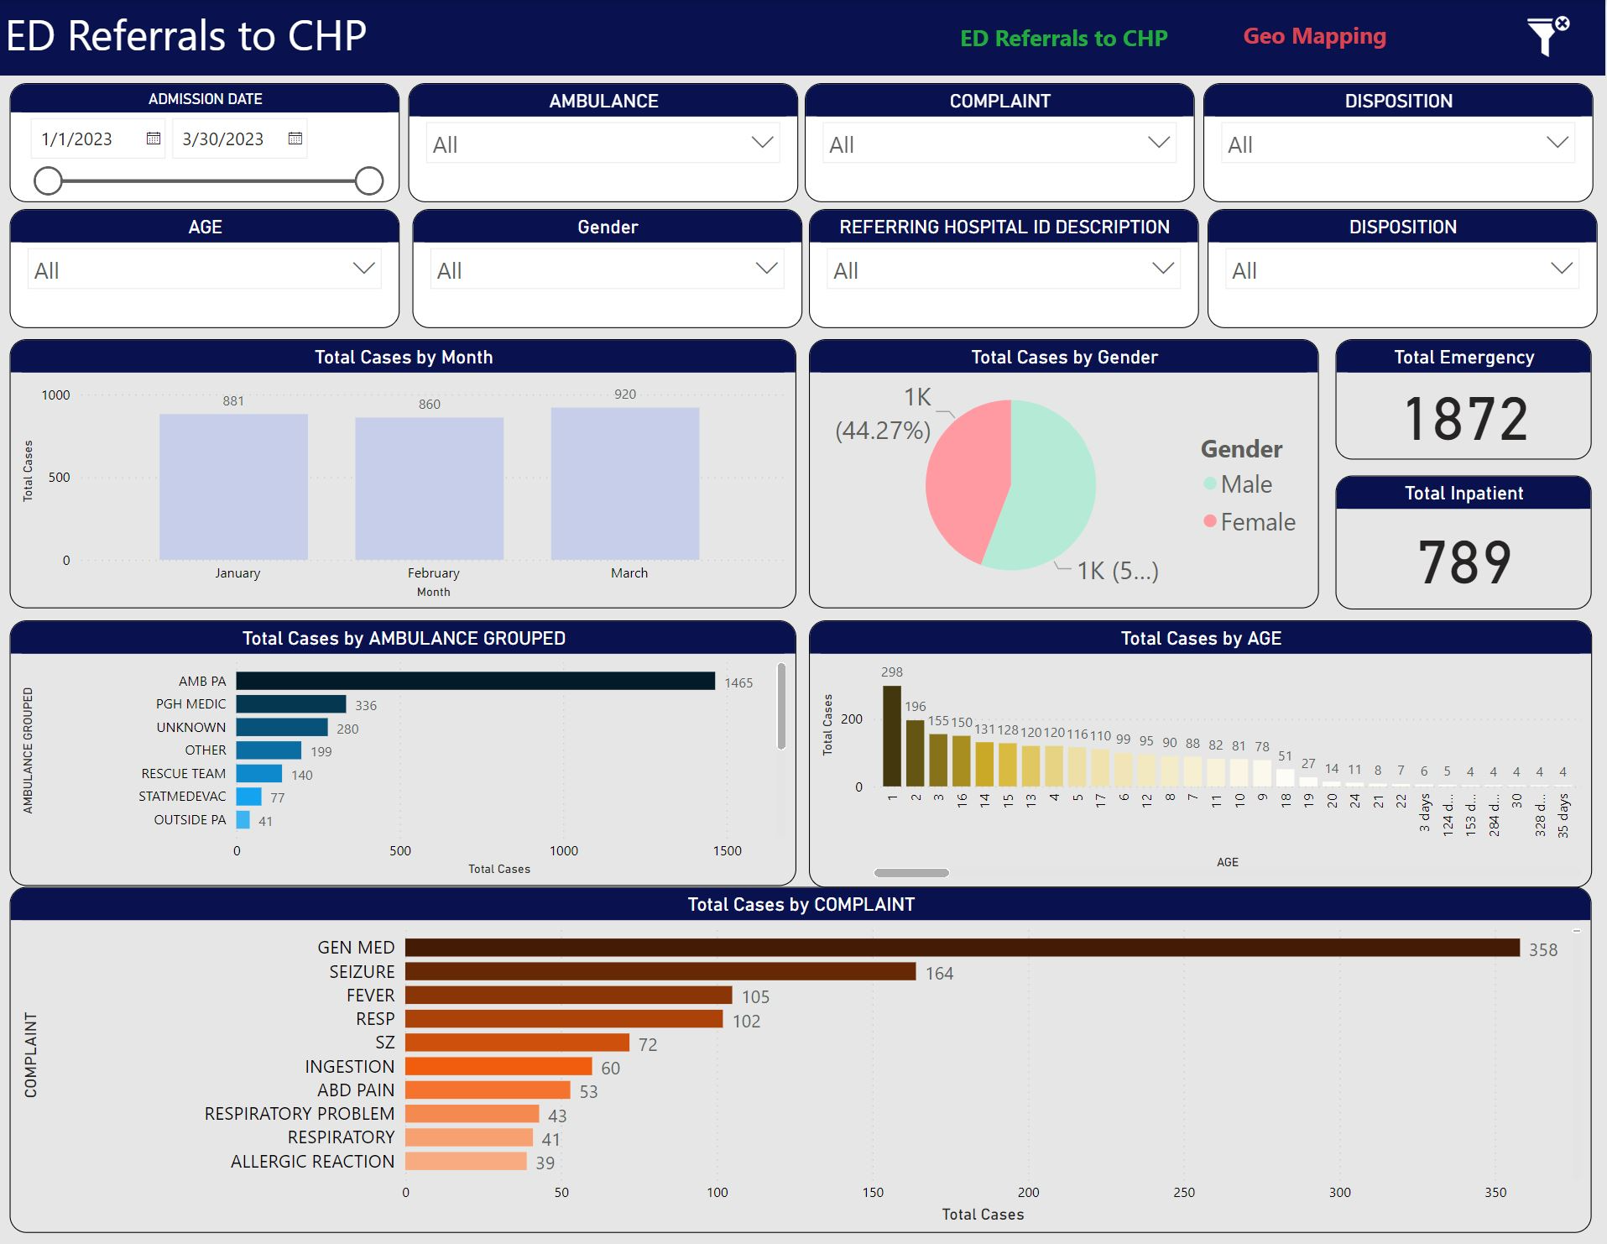

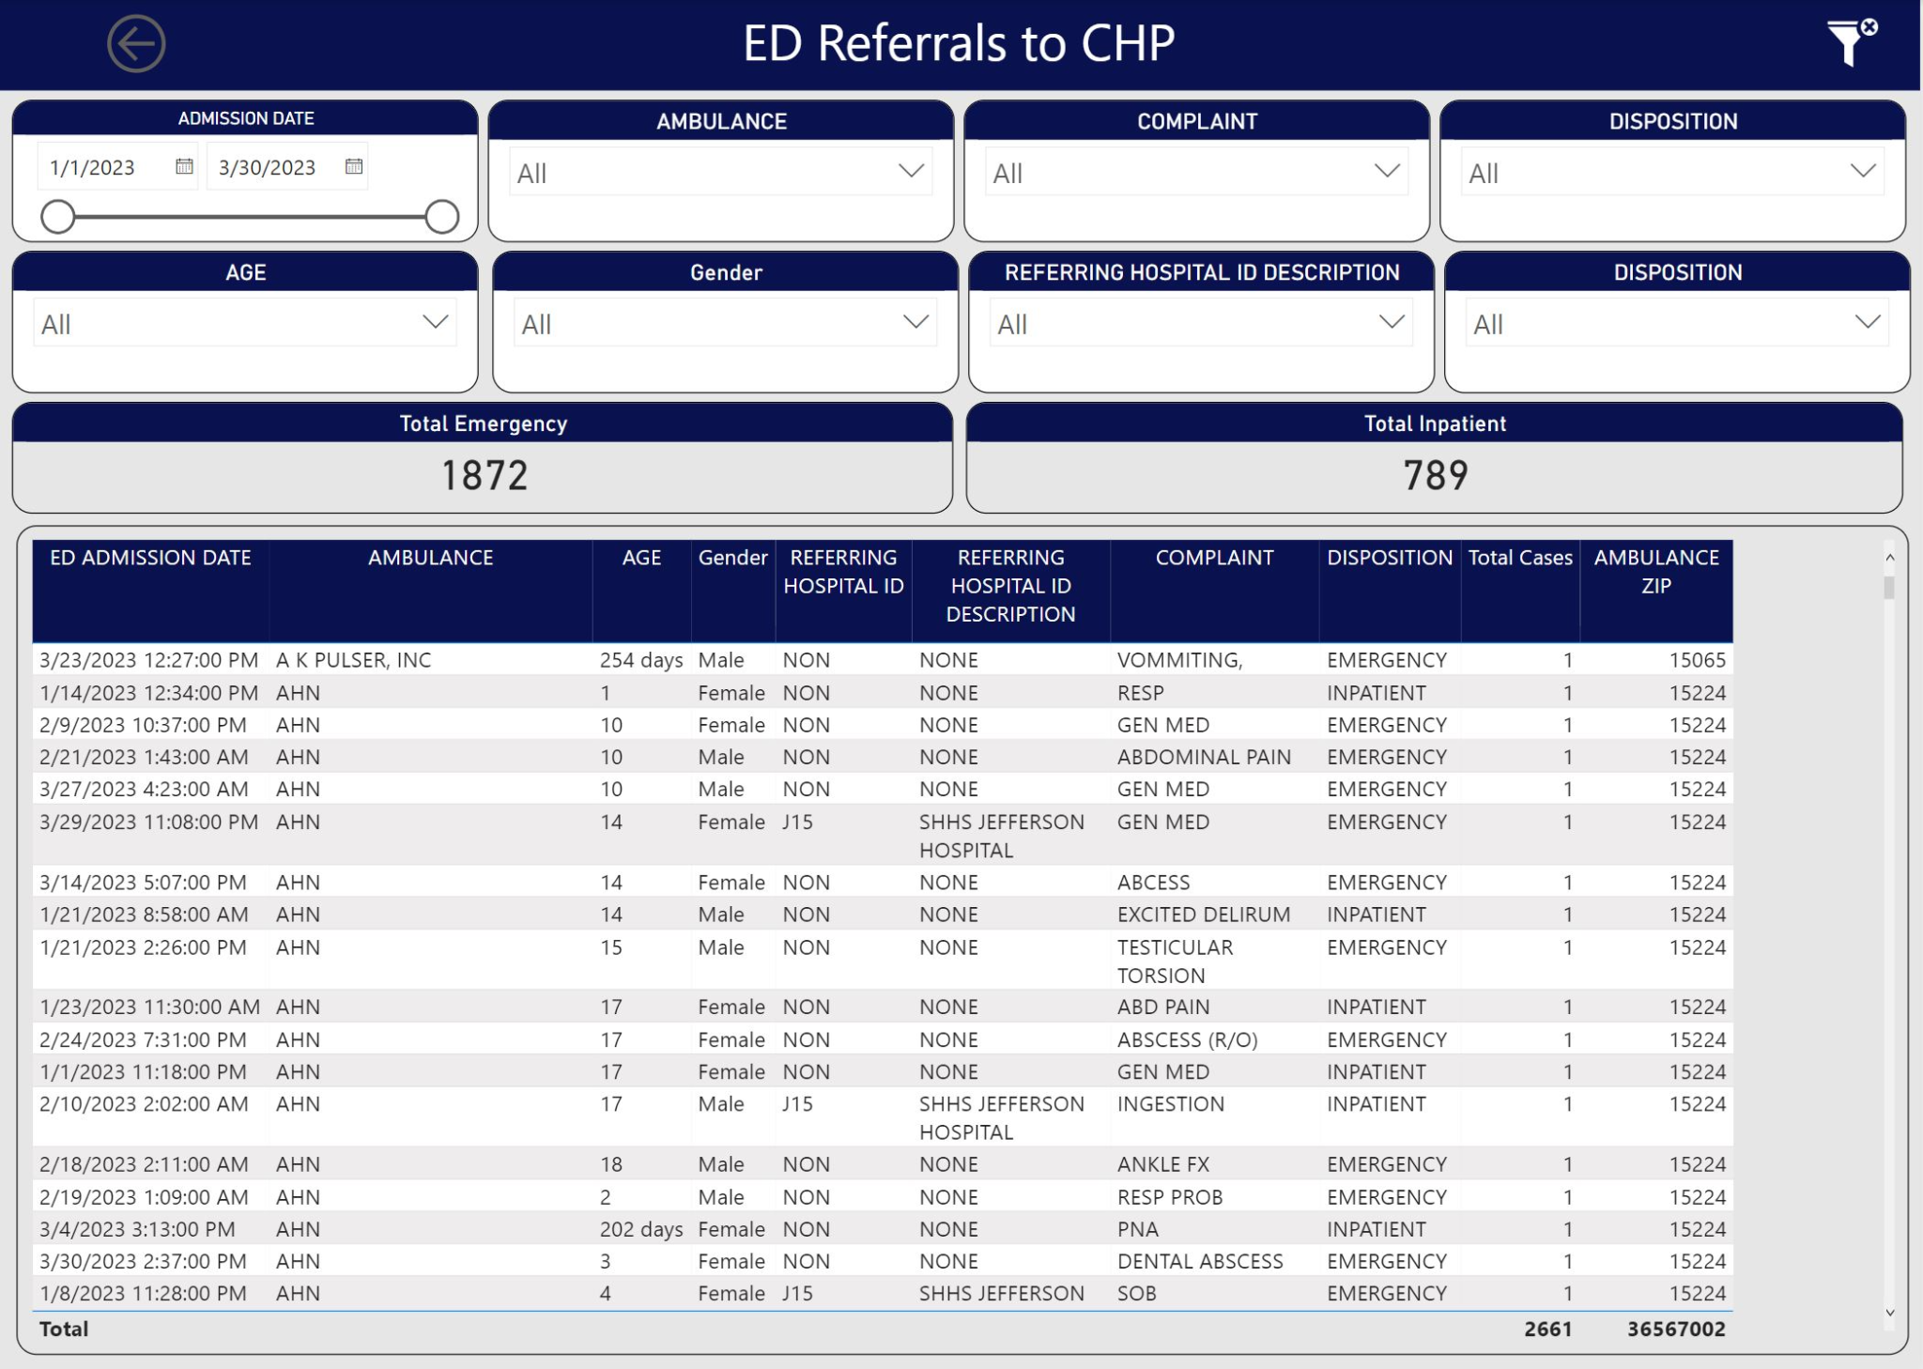

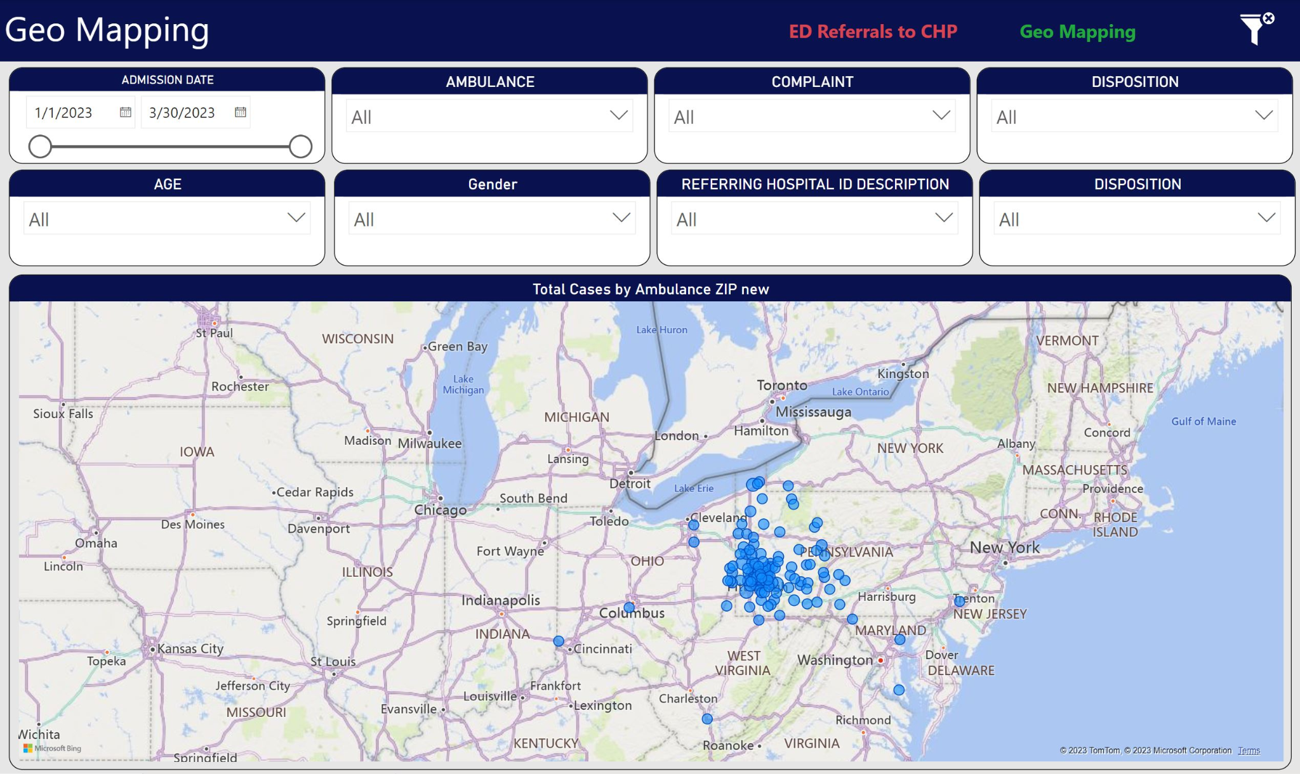

In summary, the data provides insights into the referral process of the Pittsburgh Children's hospital. It is evident from the analysis of the data that the referrals occur more frequently for patients aged between one and three years. Additionally, the majority of the referrals are from emergency with 1,872 cases and there was a total of 2,661 cases. When ED admission dates are broken down by month, March had the most cases (920), and when they are broken down by day of the week, Tuesday had the most cases (423). Most cases were admitted to the ED around 8 o'clock, according to a breakdown of admission dates by hour. Furthermore, the data presents the most common reasons for complaints to the hospital, with the top three being general med, seizure, and fever. The findings also indicate that patients referred to this hospital are spread across multiple different ambulances, with no single ambulance accounting for the majority of the referrals. In conclusion, the data plays a critical role in revealing important patterns within the referral process in a medical setting. By leveraging Power BI as a tool for analysis, it is possible to uncover these patterns and create insights to guide healthcare practitioners and administrators in their decision-making. Therefore, this project has demonstrated the potential for data analysis in the healthcare sector to improve the quality of care and accessibility for various communities.

**Recommendations**:

Based on my analysis, I recommend that Children's Hospital of Pittsburgh continue to utilize the Power BI tool and develop additional dashboards that can provide data-driven insights into patient referrals. I believe that such technology can greatly enhance the hospital's ability to manage patient care, reduce costs, and improve outcomes. Additionally, I would recommend that the hospital invest in training programs to help staff and providers better understand how to use and interpret the data provided. Lastly, the hospital should continuously monitor the reasons for the visit and complaints, to identify patterns and develop interventions to improve the quality of care provided to patients.

Most importantly, healthcare organizations should ensure that the data they use in Power BI is HIPAA compliant. Specifically, healthcare organizations should encrypt data and limit access to authorized personnel only. Moreover, healthcare organizations should ensure that any data shared outside the organization is de-identified to protect patients' privacy.

**Conclusion**:

The dashboard I developed using Power BI for Children's Hospital of Pittsburgh allowed me to gather valuable insights into patient referral trends while maintaining compliance with HIPAA and PHI laws. This information could help medical professionals create targeted staffing plans and develop more effective response plans for patients in critical situations. Additionally, the geographical distribution of ambulance zip codes and referral volumes allowed us to identify areas requiring additional attention. I believe that this project provides a solid foundation for continued investigation into healthcare analytics and can be a valuable tool for healthcare organizations looking to enhance their understanding of patient referral trends.

Through the project, I was able to acquaint myself with various tools, functionalities, and technologies available within Power BI, which helped me to mine, transform, and visualize the data. As a result, I was able to design an intuitive and interactive dashboard that not only provided critical insights into the hospital's 3-month referral data but also demonstrated the potential of Power BI in facilitating decision-making processes. The project outcome has highlighted the importance of leveraging data analytics resources for transforming complex data into actionable insights that can aid in enhancing hospital performance.

Overall, the project has not only enhanced my knowledge and skills in Power BI but also equipped me with the essential analytical, data transformation, and data visualization techniques needed in solving problems in the healthcare industry. Through the capstone project, I have demonstrated that with the proper utilization of the right tools, organizations can analyze their data and convert it into information that can drive informed decision-making leading to enhanced performance, better quality of care, and outstanding patient outcomes.

**Reference**:

Khanna, A., Gupta, D., & Dey, N. (2021). *Applications of big data in healthcare: Theory and practice*. Academic Press, an imprint of Elsevier.

Kulkarni, A. J. (2020). *Big Data Analytics in Healthcare*. Springer.

Madsen, L. B. (2014). *Data-driven healthcare: How analytics and Bi are transforming the industry*. John Wiley & Sons.